Chapter One – The Challenge of Natural Hazards
1.1 Types of Natural hazard.
1.2 Factors affecting hazard risk.
1.3 Global distribution (where they are) of earthquakes and volcanic eruptions
1.4 The physical processes taking place at different types of plate boundaries (constructive, destructive and conservative) that lead to earthquakes and volcanic activity.
1.5 Contrasting tectonic hazard case studies
1.6 Reasons why people continue to live in areas at risk from tectonic hazards.
1.7 How monitoring, prediction, protection and planning can reduce the risks from a tectonic hazard.
1.8 Tropical storms – what, where and why.
1.9 How climate change might affect the distribution, frequency and intensity of tropical storms.
1.10 A case study of a tropical storm Haiyan
1.11 Types of weather hazard experienced in the UK – Depressions
1.12 Evidence that weather is becoming more extreme in the UK.
1.13 Extreme weather event in the UK – St Jude storm of 2013
1.14 Evidence for climate change
1.15 Natural and human causes of climate change:
1.16 Managing the impacts of climate change: MITIGATION & ADAPTATION

©Robert Gamesby http://www.coolgeography.co.uk
  - Types of Natural hazard.
This unit is all about Natural hazards. AQA define natural hazards as;
“A natural event (for example earthquake, volcanic eruption, tropical storm, flood) that threatens people or has the potential to cause damage, destruction and death.”
The key part of the definition is the threat to human populations and their properties. There are many natural events around the globe that do not occur in close proximity to people so do not pose a hazard. When natural events occur close to large or vulnerable populations we have a natural hazard on our hands.
There are different types of natural hazards that can affect people around the globe, including;
- Atmospheric hazards - Created in the atmosphere, by the movement of air and water
- Terrestrial/Geological hazards - Created by the movement of the Earth's tectonic plates or surface rock and soils
- Water based hazards - Created by rivers, sea or oceans
- Biological Hazards - Any biological substance that poses a threat to the health of people

Nine deadliest natural disasters since 1900
Rank | toll (estimate) | Event* | Location | Date
1. | 1,000,000–4,000,000 | 1931 China floods | China | July 1931
2. | 450,000 (242,000–655,000) | 1976 Tangshan earthquake | China | July 1976
3. | 375,000 (250,000–500,000) | 1970 Bhola cyclone | East Pakistan (now Bangladesh) | November 1970
4. | 280,000 | 2004 Indian Ocean earthquake and tsunami | Indian Ocean | December 26, 2004
5. | 273,400 | 1920 Haiyuan earthquake | China | December 1920
6. | 229,000 | Typhoon Nina—contributed to Banqiao Dam failure | China | August 7, 1975
7. | 160,000 | 2010 Haiti earthquake | Haiti | January 12, 2010
8. | 145,000 | 1935 Yangtze river flood | China | 1935
9. | 142,000 | 1923 Great Kanto earthquake | Japan | September 1923
(source - http://en.wikipedia.org/wiki/List_of_natural_disasters_by_death_toll )

  - Factors affecting hazard risk.
The risk posed by a hazard is affected by many things. Not all earthquakes have the same impact the world over for example, and not all tropical storms are deadly. Why is it that earth quakes of the same magnitude have different death tolls? Why is it that hurricanes of the same magnitude create different amounts of economic damage? Some places are more VULNERABLE to natural hazards and some places have a lower CAPACITY TO COPE as they have weaker infrastructure, poor government organisations and agencies (such as the army, or police) or low quality equipment.
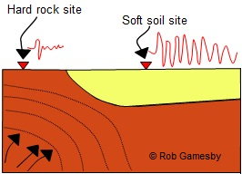
The major things affecting all natural hazards are;
- Natural factors - things like rock type (geology) in an earthquake, the shape of a coastline in a tsunami, the height of the land hit by a tsunami can influence the effects. For example, a gently sloping coastline will often suffer more damage than a steep coastline in a hurricanes storm surge. It is known that generally earthquake shaking in soft sediments is larger and longer than when compared with the shaking experienced at a "hard rock" site. Softer sediments are more likely to liquefy too, which can contribute to building collapse.

- Magnitude - the size of the event massively affects the impact it has. A hurricane of magnitude 5 on the Saffir Simpson scale will have more impact than that which has a magnitude 3, whilst every step up the Earthquake Richter scale represents a 10 fold increase in damage and a 30 fold increase in energy released.
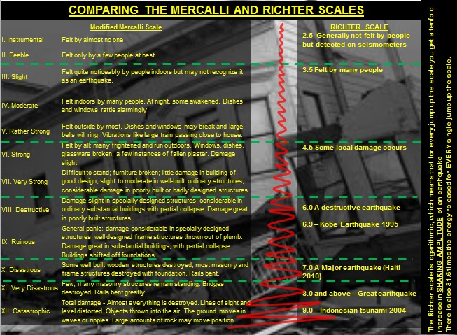
- Frequency – this is how often the hazard occurs. The more often a hazard occurs generally the more prepared people are, and the more used to coping they are. Large earthquakes and volcanic eruptions are generally very rare events in terms of a human lifespan so when they occur they can surprise. Floods are often regular events, large parts of Bangladesh flood every year for example. In this event people can adjust their buildings and lives to cope with the risk associated.
- Population density and distribution – this is the number of people in an area and where they are. Generally, the greater the number of people in an area, the greater the potential for disaster. Therefore, an earthquake in Alaska will have less impact than one which hits a more densely populated area such as San Francisco. The Pacific Ring of fire covers a 40,000km horseshoe shape and has around 90% of the world’s earthquakes and 452 volcanoes. Hundreds of millions of people live in this zone, including over 20 million people close to Popocatépetl volcano in Mexico.
- Level of development of the place - this determines how much money is available to PREPARE for the event in advance in terms of predicting the hazard and PREPARING people to cope with it, and also determines how the country RESPONDS after the event, wealthy places tend to respond quicker. High Income Countries (HIC) are generally much better at preparing and responding to natural hazards because;
- Governments – their governments are often stable and democratic and have lots of agencies that can help during an emergency. Being democratic means that the public can put pressure on the government to have life safe buildings that survive natural disasters, or makes then want to respond quickly as it will help get the politicians votes.
- Technology – HICs can afford the technology to help them predict events, the USA has the United States Geological Survey to collect earthquake data from seismometers for example. They also have the technology to help buildings survive various natural hazards
- Planning laws – many HICs have laws that prevent building in hazardous locations, along a low coastline at risk from storm surges in a hurricane for example.
- Agencies – many HICs have agencies that can act quickly to help people after a disaster, such as a well-equipped army or fire service and experts to coordinate a response in both the short and long term.

- Management – the 3Ps (Predict, Prepare and Prevent)
Predict – some natural hazards are easier to predict than others, hurricanes can be identified by satellites and then tracked. This allows governments to evacuate if needed.
Preparations - if a place is well prepared regardless of its level of development this can limit the impact of a hazardous event. In India, despite its low level of economic development, rounded wooden houses have been designed to be earthquake proof, thus limiting the impact of these hazards.
Prevent – this could be preventing damage to buildings etc. through strict building rules.
- Education – regardless of level of development people can be educated to survive natural hazards. Education about the risks of contaminated flood water or Earthquake drills (like the ones Japan has on the 1st September to commemorate the 1923 Tokyo Earthquake) can save many lives.

- Time - the amount of time since the last hazardous event can influence the impact, if a long time goes by people can be unprepared. Also, if the hazard occurs when lots of people are asleep they can also be unprepared. The Christchurch Earthquake of 2011 happened during the day when lots of people were at work, this contributed to the death toll as many got trapped in collapsed office buildings.

1.3 Global distribution (where they are) of earthquakes and volcanic eruptions
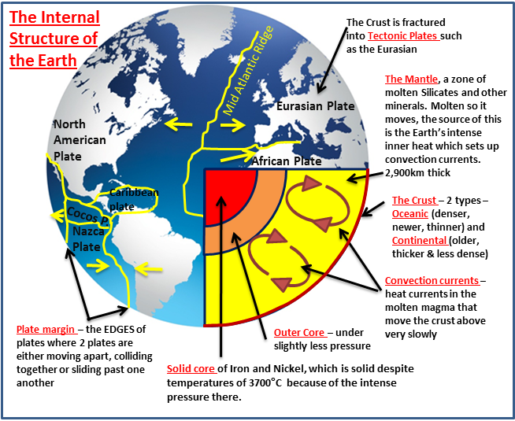
Plate Tectonics and the structure of the Earth
Tectonics is a theory that tries to explain how the Earth is structured and what it is made up of.
To the right is an idealised diagram of the Earth's interior (middle bit). The Earth formed approximately 4.5 billion years ago following a huge explosion of a star. The materials that make up our earth slowly gathered together due to gravity, to create a ball of hot molten material. This material has slowly cooled over geological time, forming a crust at the Earth's surface of rocks. These rocks are fractured into huge segments called Tectonic plates.
These tectonic plates are moving about very slowly, pushed and shoved around from underneath by currents within the mantle called convection currents.
Beneath the crust temperatures start to rise as you descend into the second of the Earth's zones, the Mantle, a zone of molten Silicates and other minerals. The Earth does have a solid core of Iron and Nickel, which is solid despite temperature of 3700°C because of the intense pressure there.
The plates and plate margins
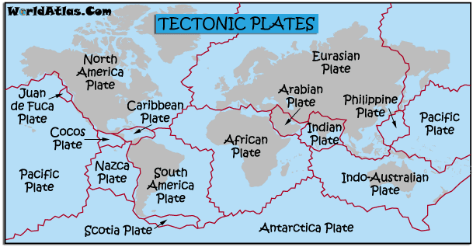
The Tectonic Plates vary in size and the Earth's surface can be likened to that of a boiled egg which has been cracked. The major plates include the Pacific, Eurasian, African, Antarctic, North American and South American, and the Indo-Australian. There are other smaller plates however, such as the Philippines and Cocos plates. The tectonic plates join at zones called plate margins, where most of the world’s volcanic and earthquake activity occurs.

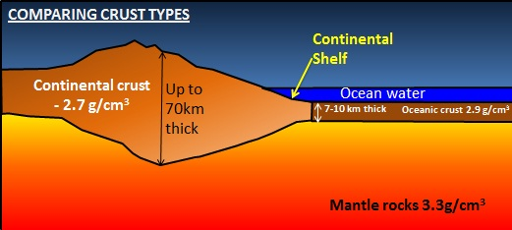
The plates are made up of different materials, and there are 2 broad types;
Continental crust is thicker, older and lighter, and is composed mainly of Granite. It is 22 mi (35 km) thick on average and less dense than oceanic crust. Continental crust is more complex than oceanic crust in its structure and origin and is formed primarily at subduction zones at destructive plate margins.
Oceanic crust is younger and heavier, and is mainly composed of basalt and Gabbro. It is mainly formed at constructive margins or spreading mid ocean ridges.
ACTIVITIES – 1.1
- Fully label the diagram below, then add one fact about each zone of the Earth’s Structure

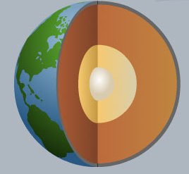

- Define the terms;
- Tectonic Plate
- Plate margin
- Contrast the characteristics of continental and oceanic crust

SCORE
1
2
3
4
5
6
7
8
9
10

COPYRIGHT NOTICE
This document is the copyrighted property of Robert Gamesby and http://www.coolgeography.co.uk
This document can be copied, revised, customised and used for the use of a PAID SUBSCRIBING SCHOOL ONLY under the conditions of the School Subscribers Agreement found at http://www.coolgeography.co.uk
PROHIBITED USES
The School shall not and shall procure that each and every Authorised User within their school does not:
- Copy, print out or otherwise reproduce any Resources (in whole or part) for any commercial use or any of purpose except as permitted under the School Subscribers Agreement or authorised in advance by Http://www.coolgeography.co.uk in writing;
- Mount or distribute any part of the Resources on any electronic network, including TES resources, Nings, file sharing sites etc.
- Remove or alter any copyright notices or means of identification or disclaimers as they appear in the Resources. This includes the BACKGROUNDS of PowerPoints which have a copyright notice on them.
- Share these resources with other schools or other colleagues outside of the paid subscribing school in any manner.
NOTE
I have spent hundreds of hours putting the resources together, please respect my work!

